Problem

Result

**SQL Query - 28**

**Problem Statement:**  
List down all the details of the orders made in February 2021 or July 2021, also sort them in ascending order by their price.

**Information about the table:**  
Attributes list: 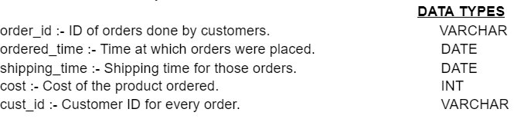  
Table **e_transactions**:

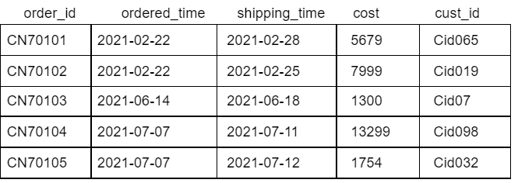

**Output Table Structure**  


select order_id,ordered_time,shipping_time,cost,cust_id

from

e_transactions e

where (ordered_time like '2021-02-%') or (ordered_time like '2021-07-%')

order by cost;

+----------+--------------+---------------+-------+---------+

| order_id | ordered_time | shipping_time | cost | cust_id |

+----------+--------------+---------------+-------+---------+

| CN70105 | 2021-07-07 | 2021-07-12 | 1754 | Cid032 |

| CN70101 | 2021-02-22 | 2021-02-28 | 5679 | Cid065 |

| CN70102 | 2021-02-22 | 2021-02-25 | 7999 | Cid019 |

| CN70104 | 2021-07-07 | 2021-07-11 | 13299 | Cid098 |

+----------+--------------+---------------+-------+---------+